UPPWISE INDIA

www.uppwise.com

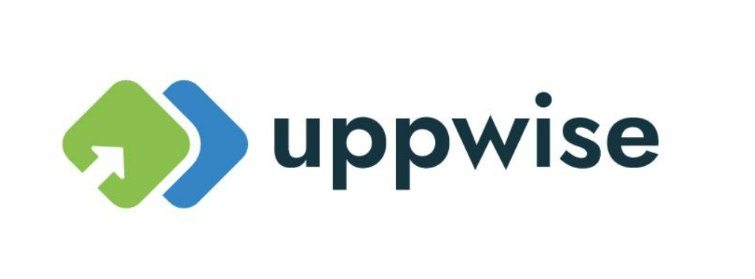

**Quaterly Development Planning**

**Q1-2024**

**Feature: Task Properties**

**Feature Title:**

Tasks Properties (chargeable, type)

**Priority:**

Medium

**Submitted By:**

SPM

**Target Users:**

SPM Standard User

**Feature Description:**

The introduced facility allows for a granular control mechanism, enabling users to distinctly mark activities as chargeable or non-chargeable. By leveraging this configuration in the Gantt chart, users can streamline their timesheet entries based on the chargeable status assigned to each activity. This ensures a more efficient and user-friendly approach to managing activities within the Timesheet module.

**Acceptance Criteria:**

The Manage Chargeable Activity feature is designed to enhance the application by providing users with the capability to define activities based on charges. This functionality introduces specific implementations that contribute to the overall flexibility of activity management.

**Key configurations which need to be added:**

1. **TT Validation Rule Configuration:**
   * Users can access the TT Validation Rule configuration page to manage the settings related to Chargeable Activities.
   * A dedicated configuration option, "Manage Chargeable Activity," is introduced, allowing users to enable or disable this feature. Setting it to "YES" enables users to manage activities with chargeable attributes.

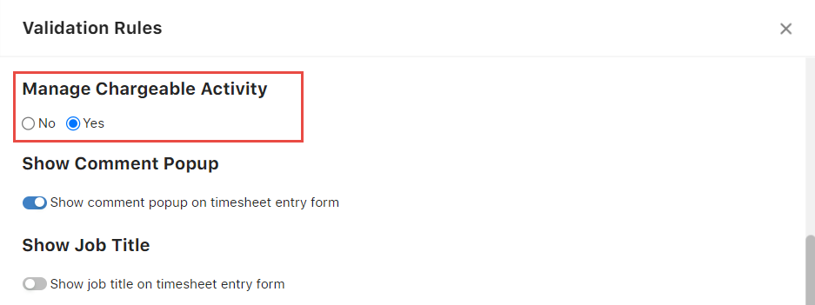

1. **Standard Code - Activity Type Setting in Initiative Management:**
   * A new standard code setting, "Activity Type," is added within the Initiative Management module.
   * This setting empowers users to create unique activity types within the application, providing a structured categorization for various activities.

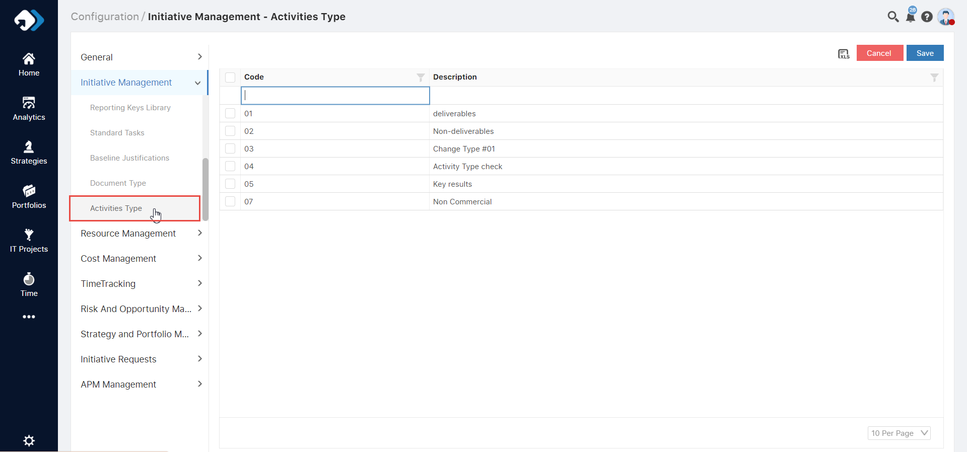

1. **Additional Columns Introduced in Gantt:**
   * Within the Gantt interface, new columns are introduced to support the Manage Chargeable Activity feature.
   * Users can now choose the activity type and mark the activity as chargeable or non-chargeable based on their preferences.

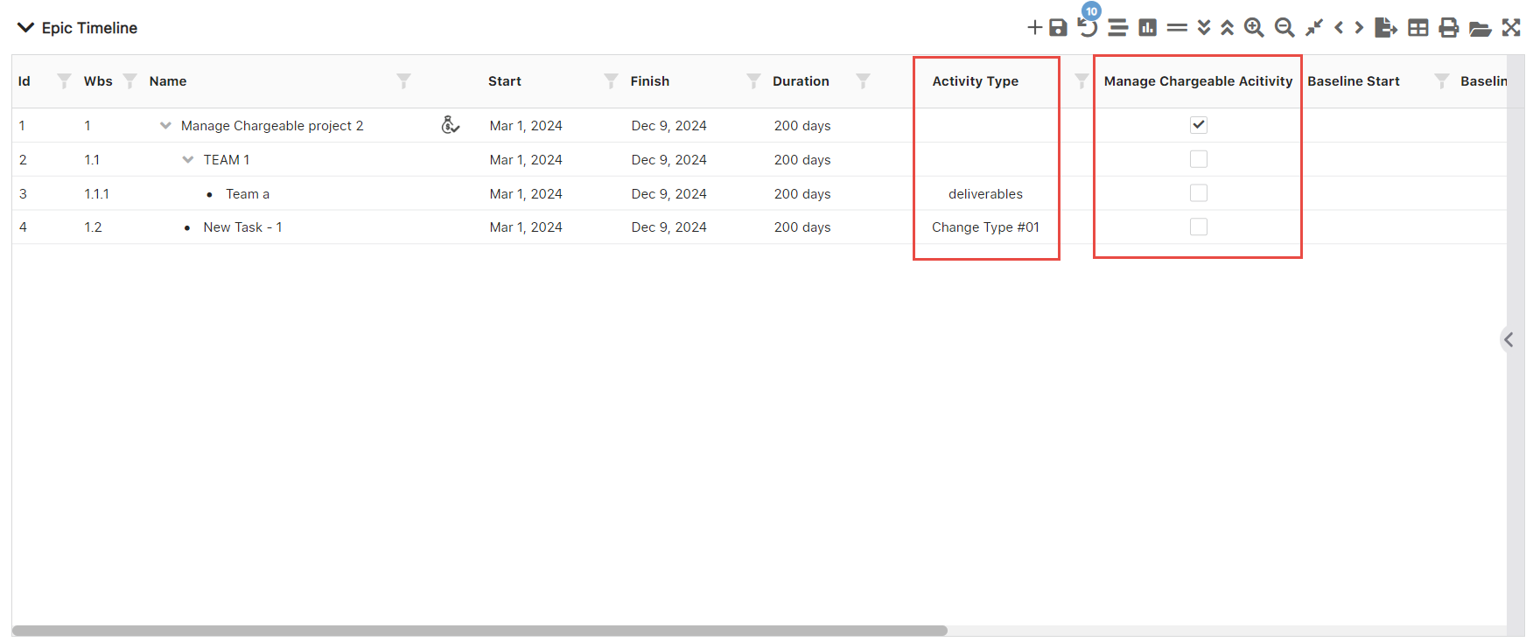

**Chargeable/Non-Chargeable Activity Configuration in Timesheet Module:**

In the Timesheet module, the ability to add a new activity is influenced by its chargeable status, which is configured in the Gantt chart. The following conditions apply:

1. **Non-Checked (Non-Chargeable) Activities:**

* If a specific activity is marked as non-chargeable (non-checked) in the Gantt chart, users will be unable to add it to their timesheet.
* This configuration provides a restriction, ensuring that only chargeable activities can be included in the timesheet.

1. **Checked (Chargeable) Activities:**

* Conversely, if a specific activity is marked as chargeable (checked) in the Gantt chart, users can add it to their timesheet.
* This configuration allows users the flexibility to include chargeable activities in their timesheet entries.